Flower Applique—Clutch Purse

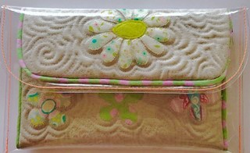
Tools
- Sewing machine
- Foot #12
- Foot # 52 OR 52C (Non Stick Sole)
- BSR OR Foot #24
- Open Toe Foot #20
- Walking Foot

Materials & Cutting Instructions
Fabric Top - Cut 1 x 23cm x 37cm plain med/heavy weight cotton fabric
Fabric Backing (patchwork fabric of choice) - Cut 1 x 23cm x 37cm cotton fabric
Batting - Cut 1 x 22cm x 36cm of batting
PVC Platic - Cut 1 x 24cm x 38cm thick PVC Plastic
Piping Fabric - Cut 1 x 1 Metre x 4cm cotton fabric (can be same as fabric backing)

Extra Materials
- 1 x 1 Metre piping cord
- Approx. 25cm x 25cm Visoflix OR Steam a Seam
- Small assortment of patchwork fabrics for the applique.

