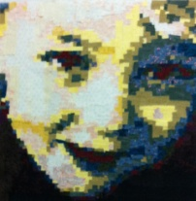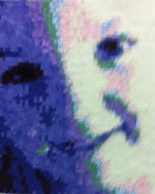Robyn Taylor
216 Fernleigh Road
WAGGA WAGGA NSW 2650

0408241175
Robyntaylor399@yahoo.com.au

Images above are approx 15” x 18” (4 x A4)

FABRIC MOSAICS

Based on a computer programme developed by Tammie Bowser.
Please visit www.quiltedphoto.com to learn more

Requirements;
- Photo for scanning (JPEG file) - someone or something that you want to turn into a Wall Hanging “WORK OF ART”.

Must have balance of light, medium and dark areas.
Preferably light shining on the side casting shadow, giving detail

Small project (one face) approx. 14” x 16” (4 x A4 fabric paper) - Class Project
Bigger projects can be negotiated @$5.00 per page A4 to be done after workshop

- Email me your photo at least a couple of months prior to the workshop and
I’ll email you back your options for discussion. Please include your phone no. and time suitable for me to ring you. I will bring your fabric grid in on the day.

- 1 ¼ metre Steam a Seam2 - Double sided fusible interfacing or
1 packet steam a seam2 (available in packs of 5 x A4) available from Shepparton Sewing Centre

- Variety – 4 light, 4 medium and 4 dark fabrics – blender or tone on tone
Max fabric size 1 x 2 ½” by WOF x 12 fabrics for one face plus additional background fabric for border in any color you like.

B & W fabric kit (for face only not border) available from Shepparton Sewing Centre Cost $30.00

- Partitioned container for storing fabrics – Minimum 12 compartments

- Sharp scissors or rotary cutter, mat and ruler for cutting fabrics

- Small ironing mat(I have a few I bring to the workshop) or extra fabric for protecting work bench.

- 50cm Quilted calico, or batting and backing for finishing wall hanging.

- Applique mat

You will need a sewing machine for the 2ndday of the workshop.

